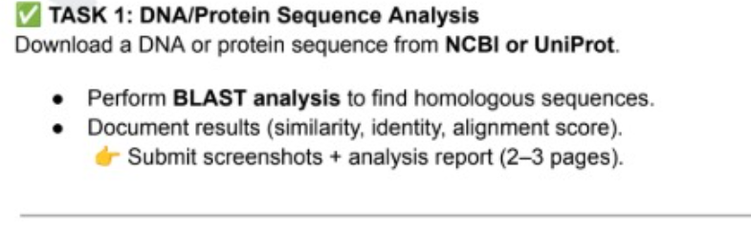****BLASTp Analysis Report of Human Insulin Isoform 2 Precursor (Homo sapiens)****

****Overview of BLASTp analysis****

**A BLASTp search was performed using the amino acid sequence of human insulin isoform 2 precursor (NP_001035835.1), consisting of 200 amino acids. The objective was to identify homologous protein sequences in other organisms and evaluate their evolutionary relationships based on sequence similarity, E-values, and domain conservation.**

****1. Alignment Summary****

**The BLASTp analysis retrieved several highly similar insulin sequences from primates and other mammals.**

**The top hits included:**

* **Homo sapiens (identical isoforms and variants),**
* **Symphalangus syndactylus (siamang),**
* **Hylobates moloch (Javan gibbon),**
* **Nomascus leucogenys (northern white-cheeked gibbon).**

**All hits demonstrated very high sequence identity, nearly complete query coverage, and extremely low E-values, confirming significant homology and strong evolutionary conservation.**

**The query coverage for all top matches ranged from 99% to 100%, indicating that nearly the entire insulin protein sequence was aligned with each homolog.**

**The percentage identity values were remarkably high 99% for human isoforms and 95–96% among other primates,demonstrating that the insulin protein is highly conserved across mammals.**

**Minor amino acid substitutions were observed in non-critical regions, particularly within the signal peptide and connecting peptide (C-peptide) areas. No significant variations were found within the A and B chains, which are essential for insulin’s biological activity.**

****3. Significance of E-values****

**The E-values ranged from 1e-137 to 3e-129, which are exceptionally low.**

**Such values indicate an extremely high degree of similarity, with an almost zero probability that these matches occurred by chance.**

**In protein BLAST interpretation, E-values below 1e-5 already suggest strong homology .hence, values in the range of 10⁻¹³⁰ demonstrate evolutionary conservation at the molecular level.**

**This confirms that the human insulin gene shares a common ancestral origin with other primate insulin genes.**

****4. Conserved Regions and Domain Analysis****

**Alignment inspection showed complete conservation of the functional motifs, including:**

**The “LVCGERGFFY” region within the B-chain, conserved across all hits.**

**The IIGF insulin like conserved domain, which is characteristic of insulin and insulin-like growth factors, was detected in all aligned sequences.**

**The absence of major gaps or insertions further supports the functional and structural preservation of insulin throughout primate evolution.**

****5. Evolutionary Implications****

**The results clearly demonstrate that the insulin protein has undergone minimal evolutionary divergence among mammals, especially primates.**

**The 99% sequence identity between Homo sapiens and other gibbon species reflects recent evolutionary divergence and strong purifying selection pressure on insulin due to its crucial metabolic role.**

**Even small differences seen in the signal or C-peptide regions may contribute to species-specific processing variations, without affecting the hormone’s functional core.**

****6. Conclusion****

**The BLASTp analysis of the human insulin isoform 2 precursor reveals:**

**Complete query coverage (≈100%),**

**Extremely high sequence identity (95–99%), and**

**Exceptionally low E-values (1e-137 to 3e-129).**